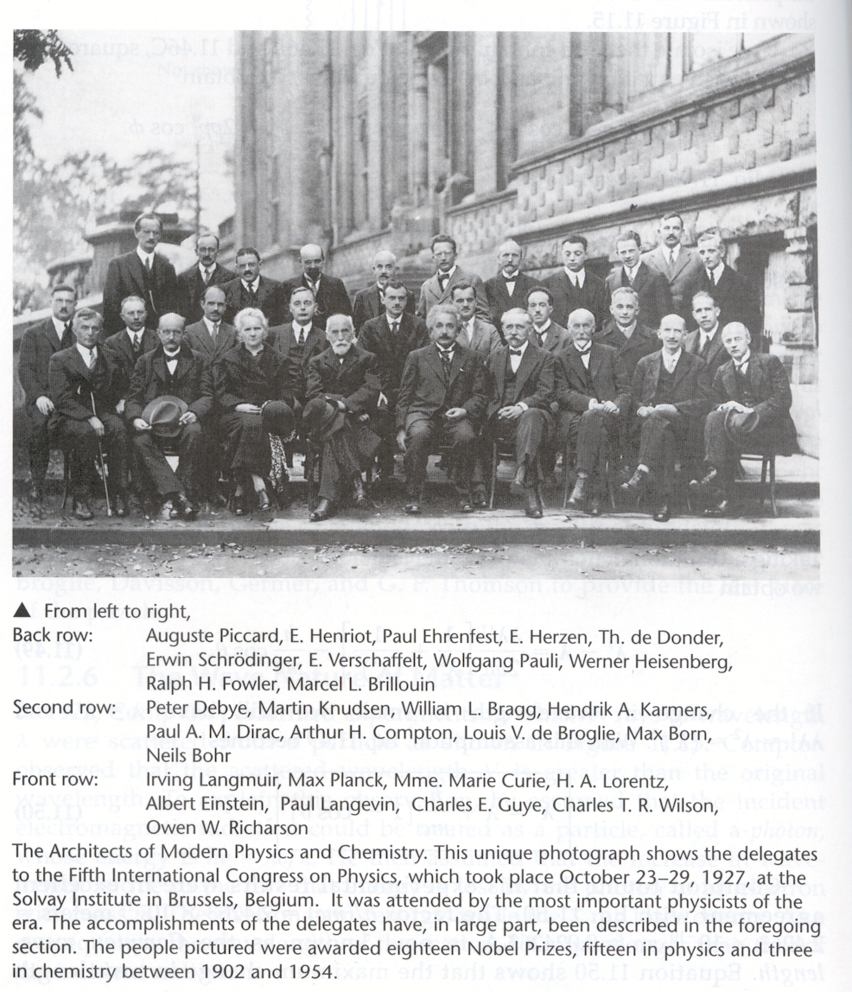There was **“nothing else remotely comparable in the annals of science.”** [**http://www.numericana.com/fame/solvay.htm**](http://www.numericana.com/fame/solvay.htm) **Marie Curie (3rd in front), won 2 Nobel Prizes.**